| Course Name | ITD 2313 – Script Programming |
| --- | --- |
| Instructor | Mark Pranger |
| Student Name | Weston Albright |
| Due date | 05/06/2025 |
| Grade | N/A |
| Grading Comments | N/A |

1. Go to the Python Org page (at the website above) and screenshot the homepage of the website.

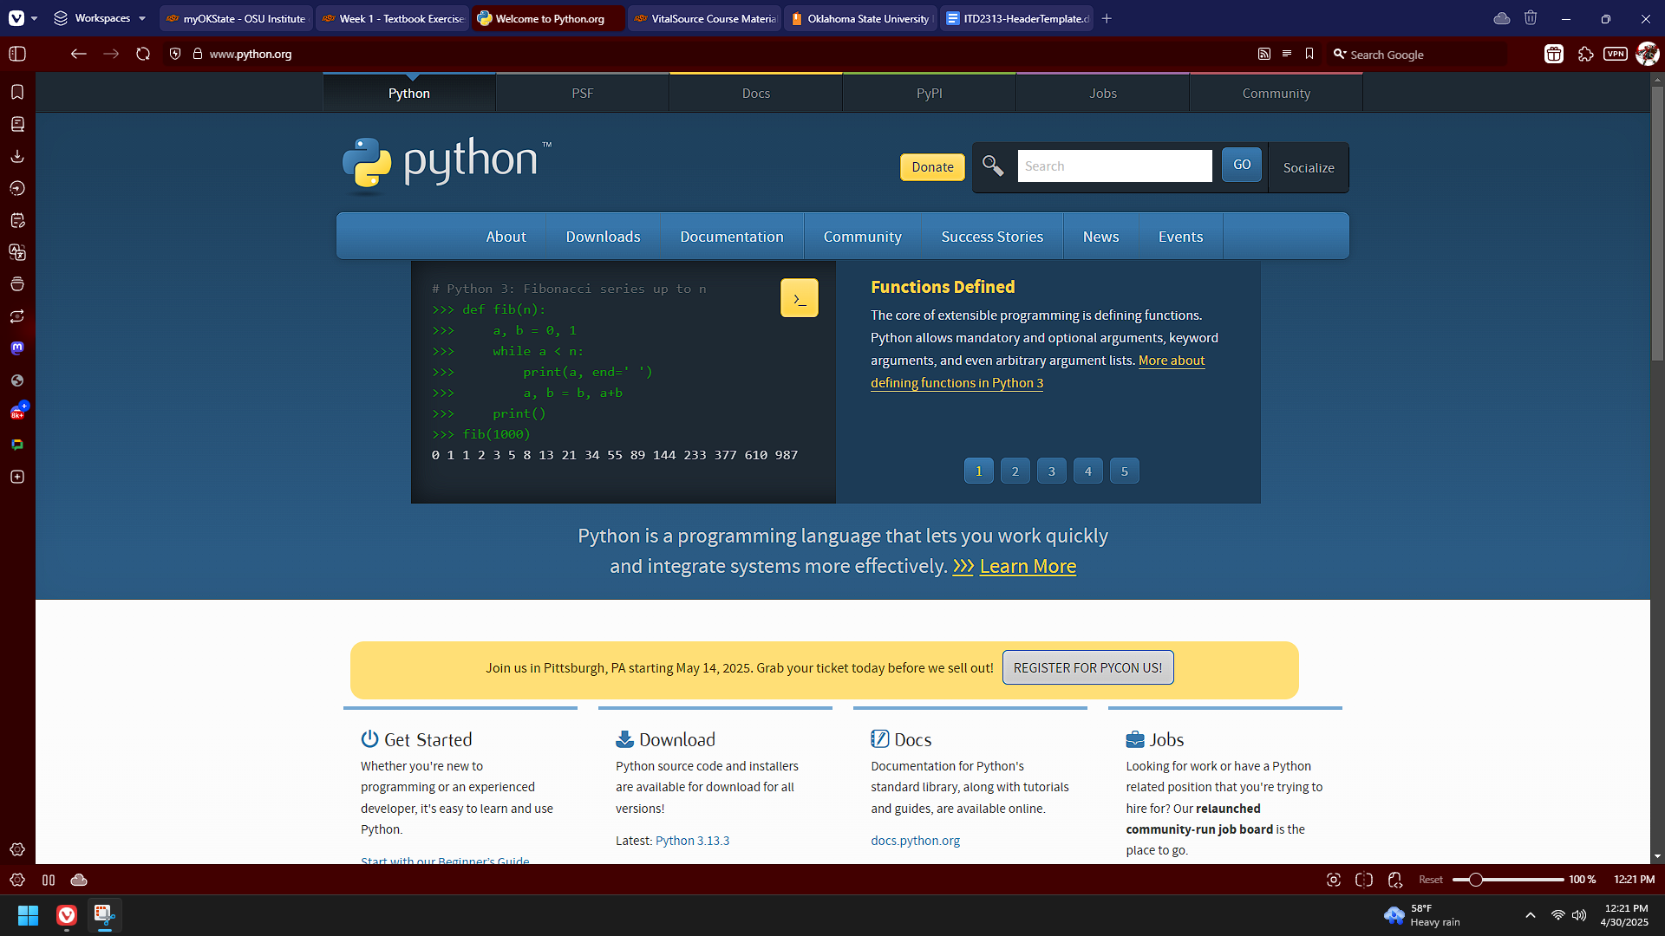

1. Click on the Downloads tab on the home page and then grab a screenshot of the download page.

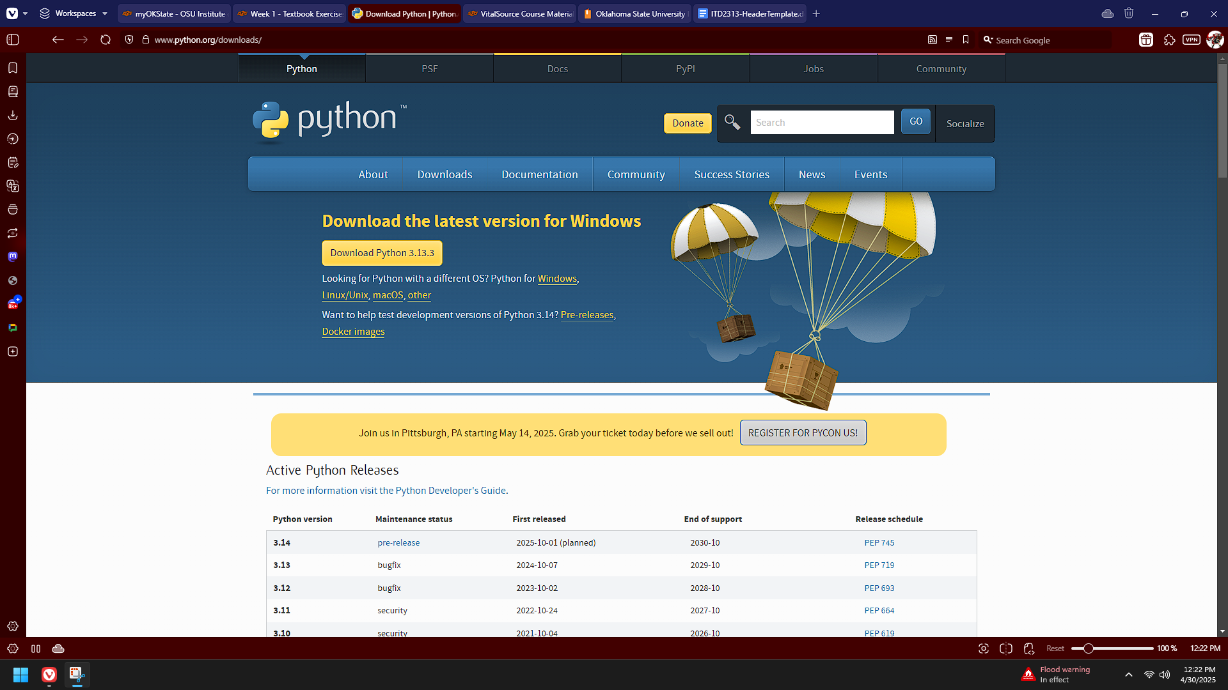

1. Download the most current version for your chosen OS and screenshot the download in progress bar

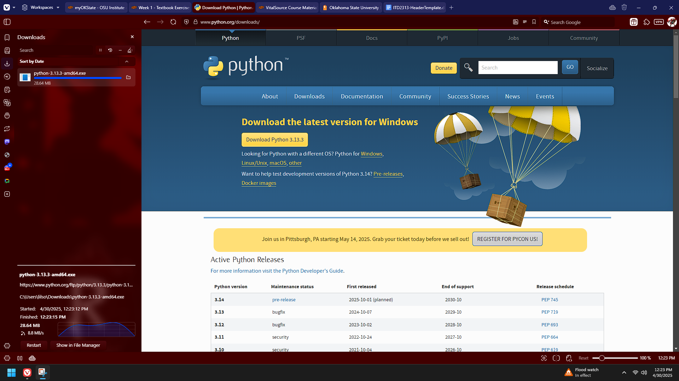

1. Once downloaded, go to your system and install Python and screen shot the installation process at some point showing that Python is installing

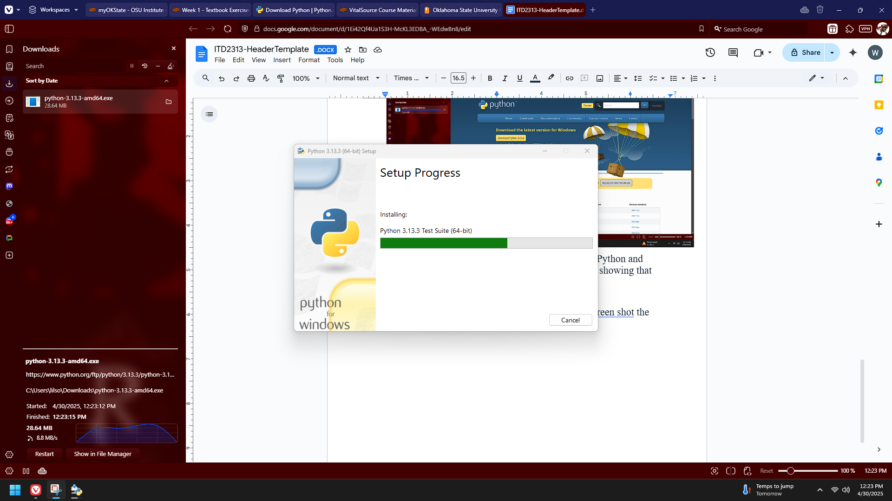

1. Finally, once it is installed, start up IDLE and screenshot the IDLE window

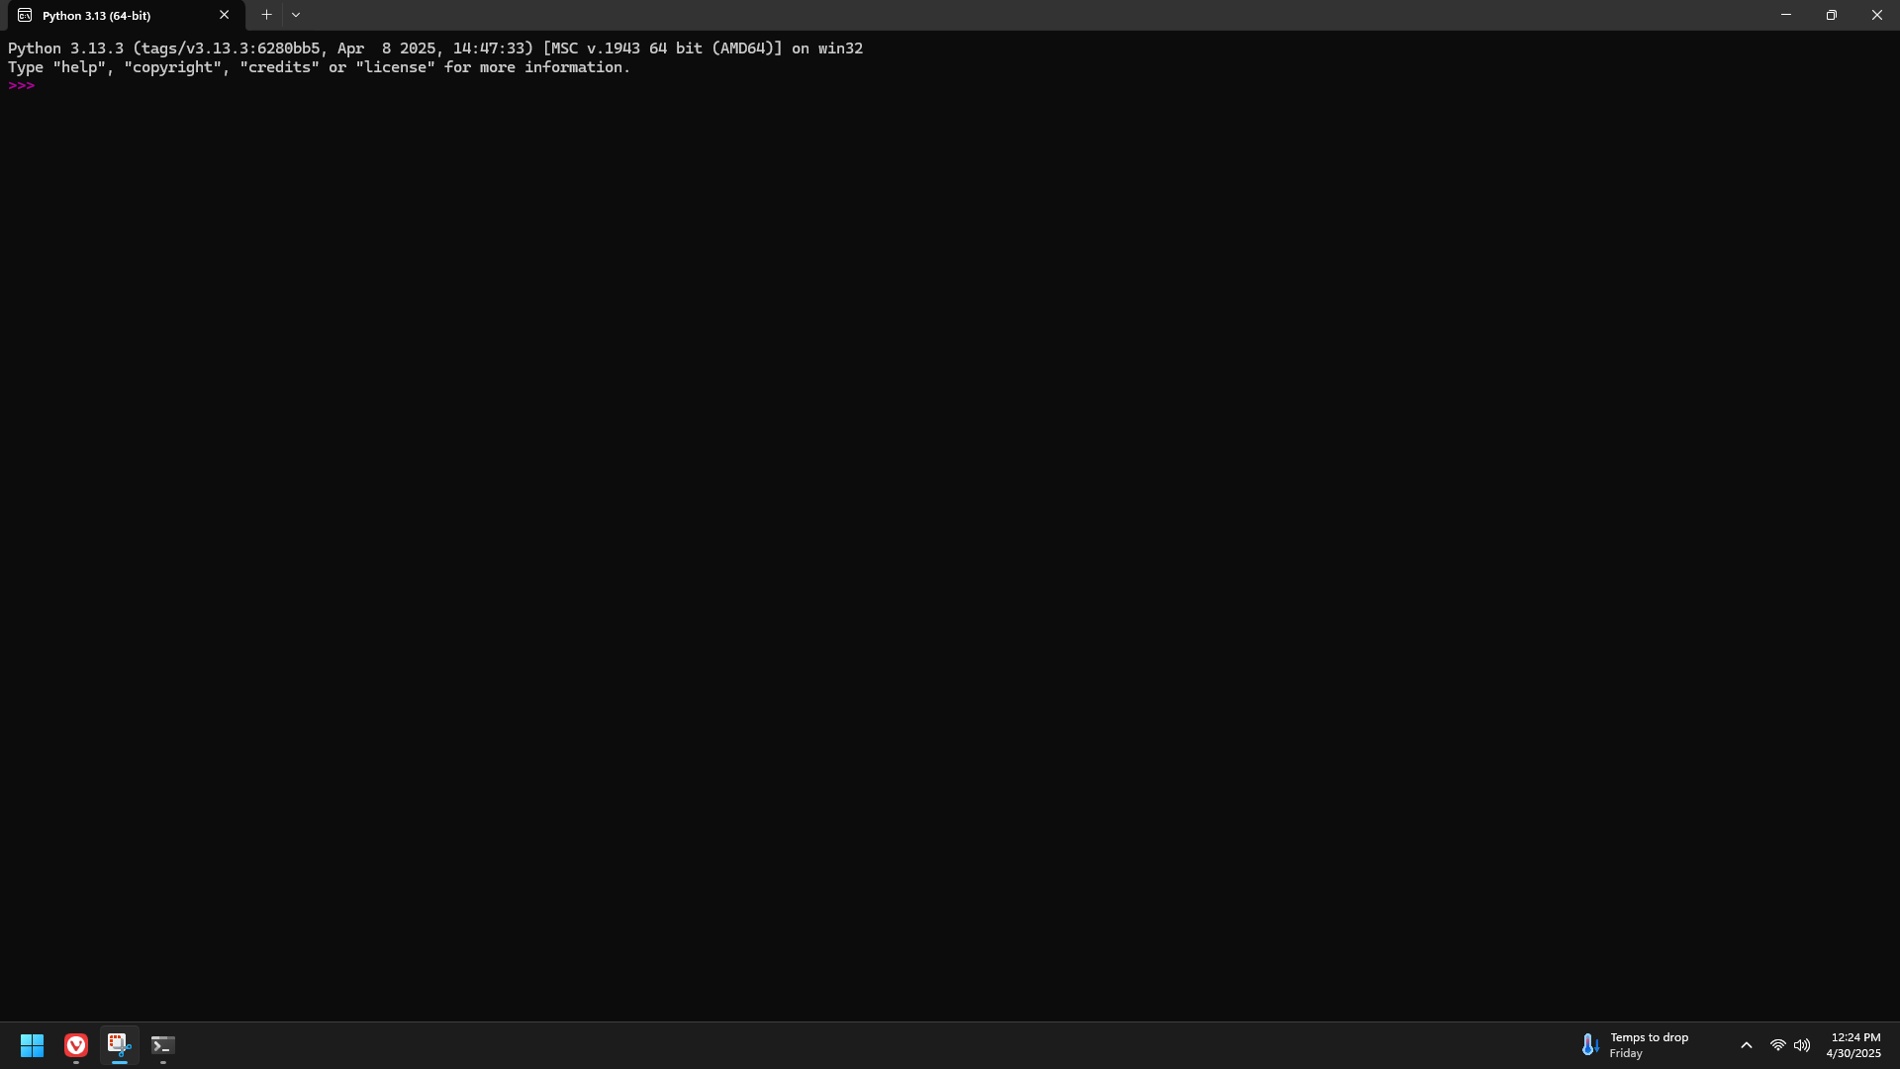

Page 17 code examples

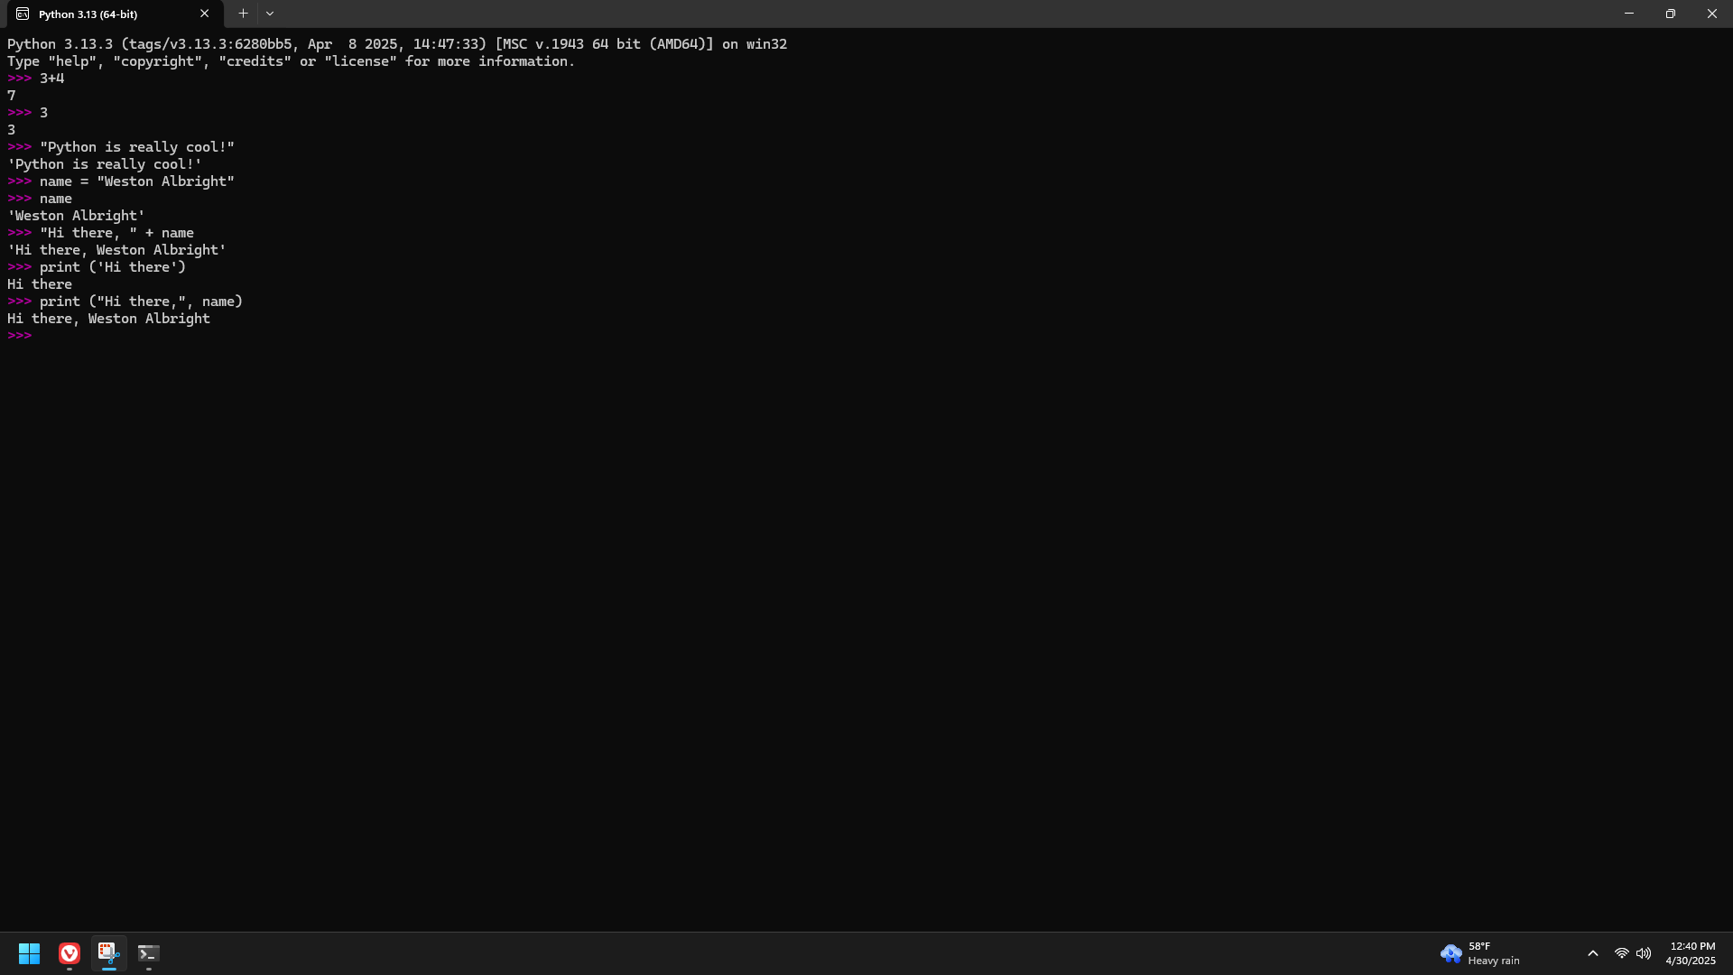

Page 18 code examples

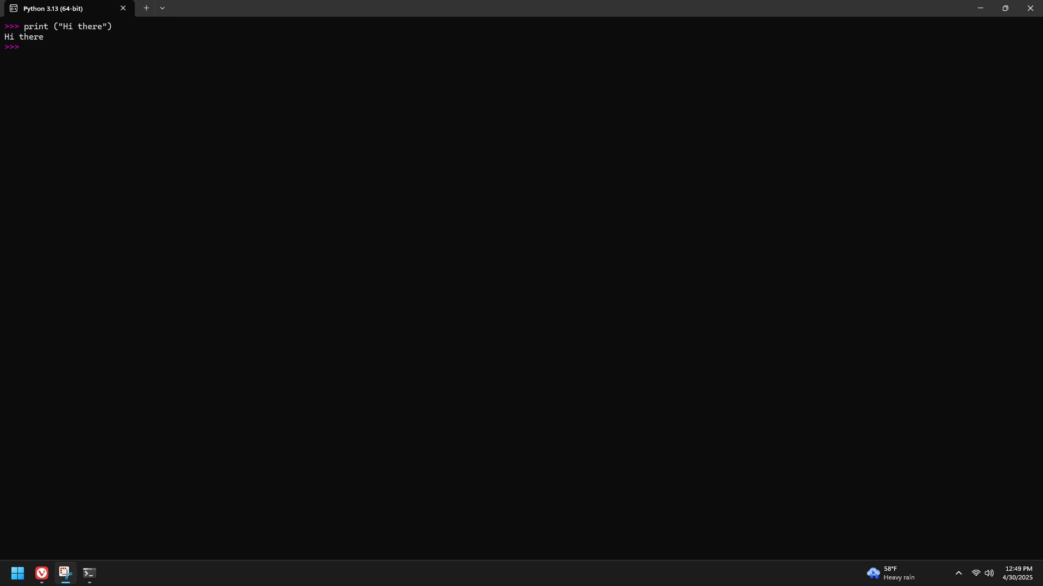

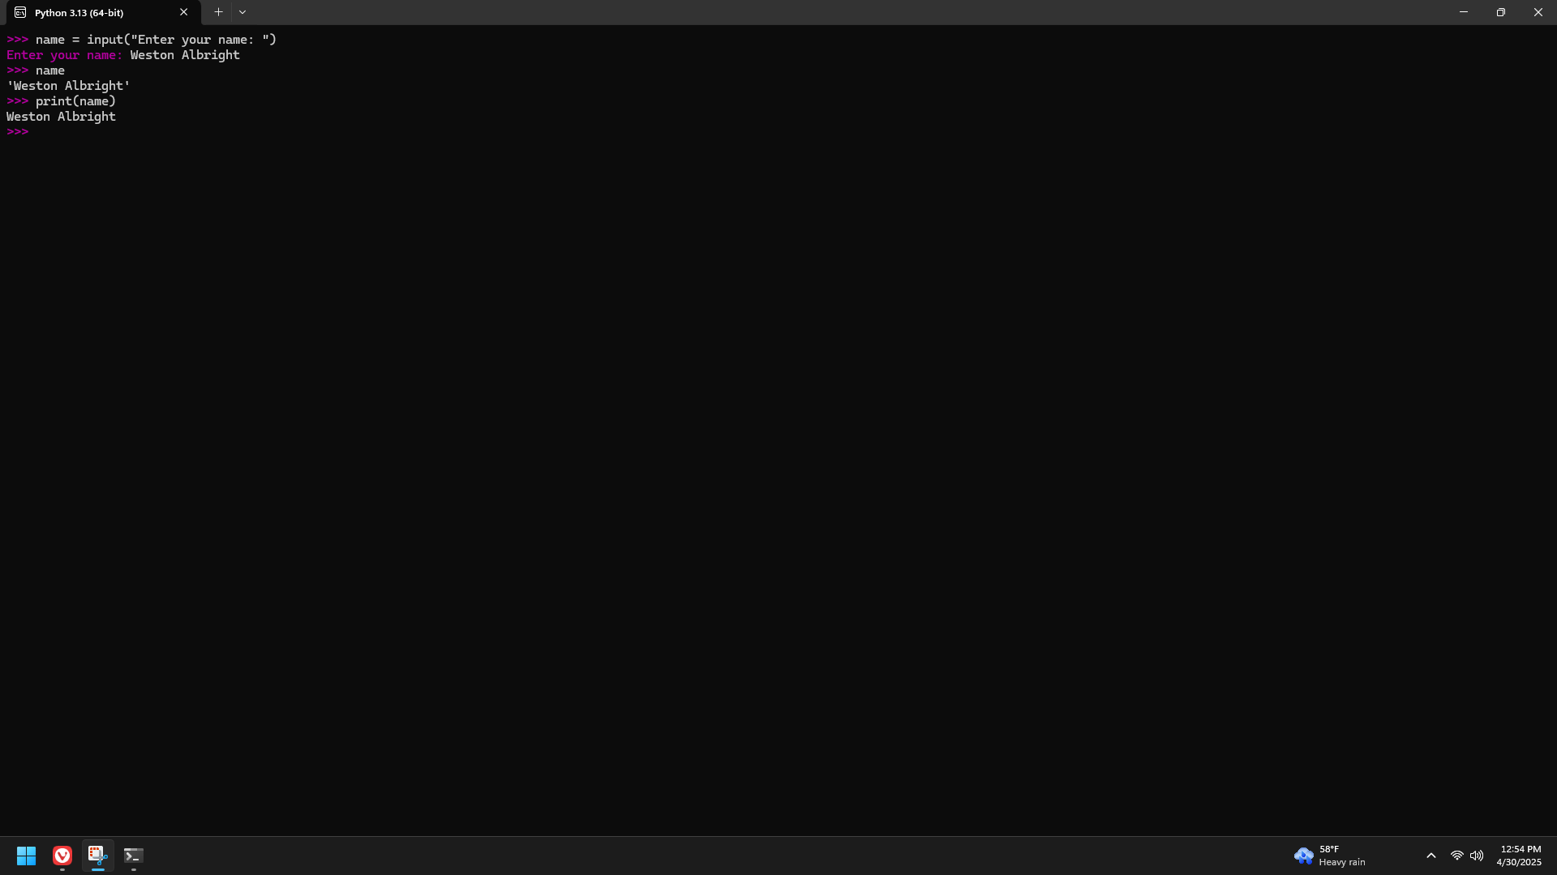

Page 19 Examples

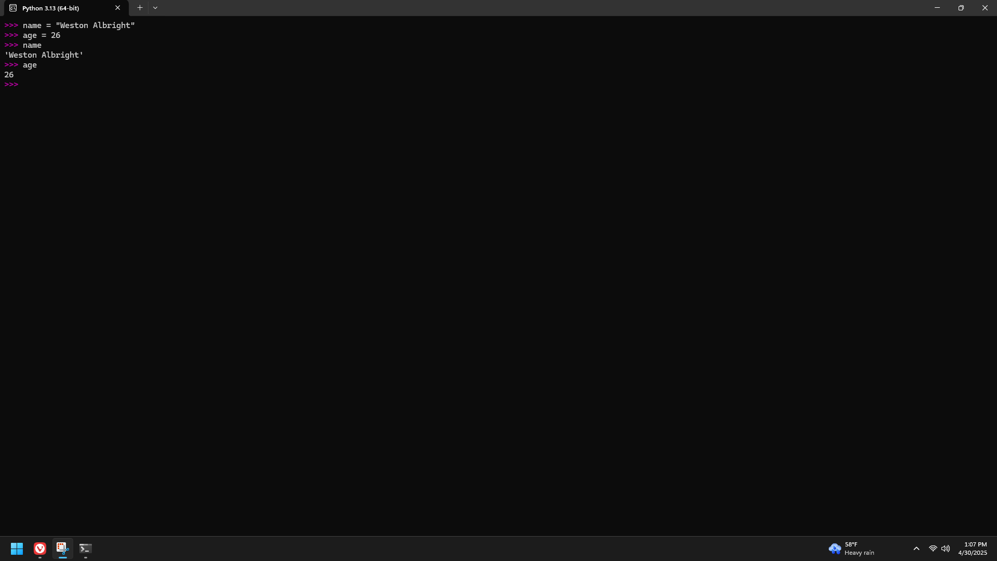

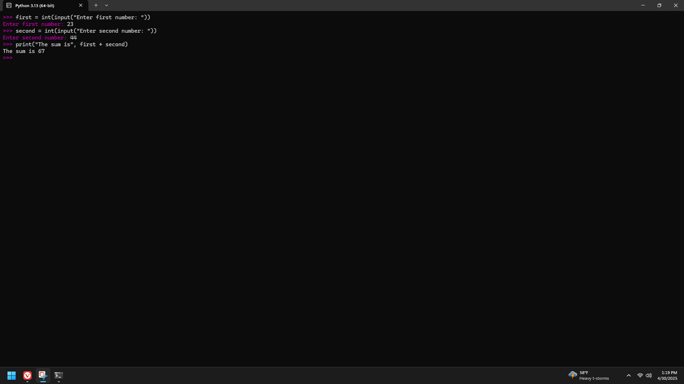

Page 20 Examples

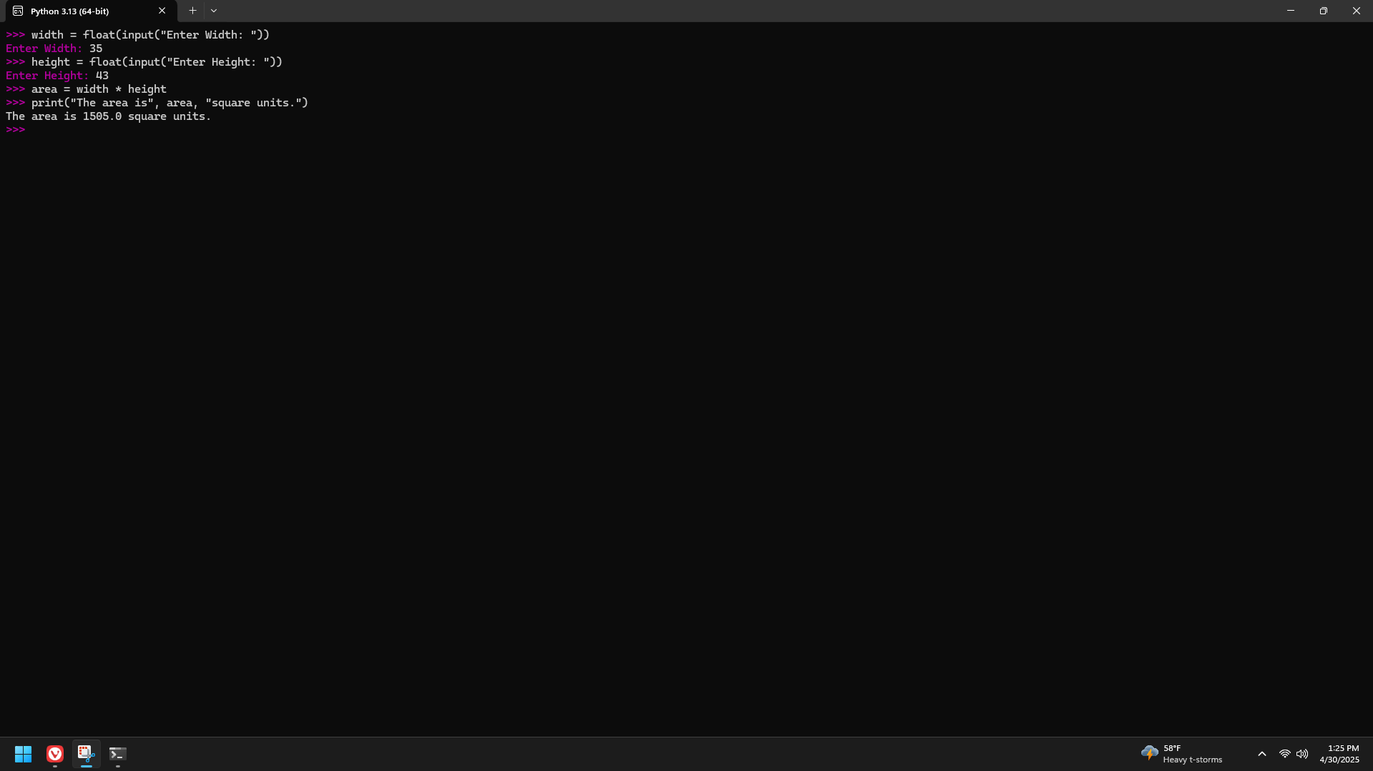

Page 21 Examples

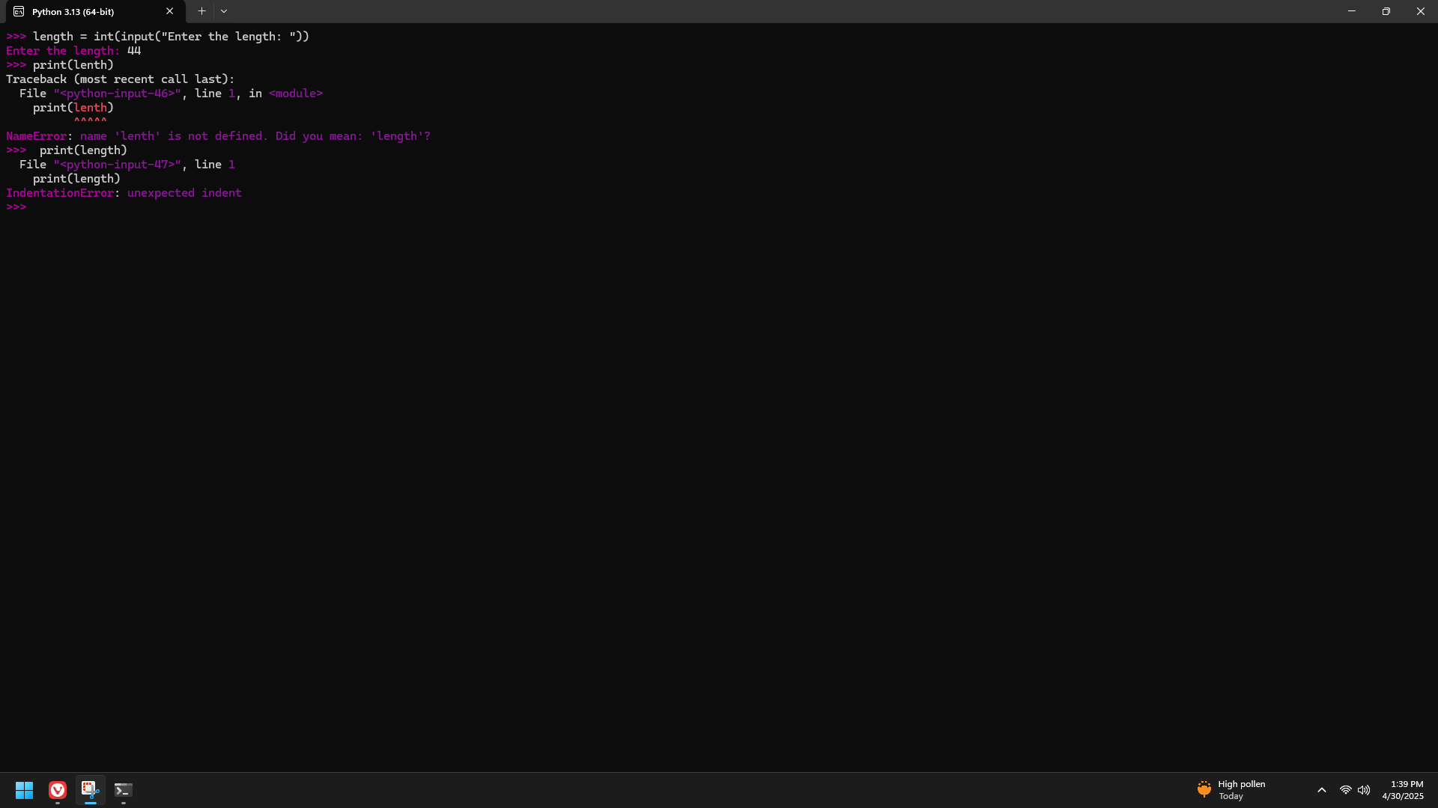

Page 22 Examples

